Welcome to the St. Patrick’s Faith Formation program
- Our Program serves children and youth in grades Kindergarten through 9.

- The Discover Program, from St. Mary’s Press, is being used for children grades K-5.
- 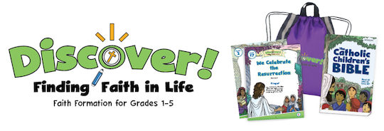

- Our 6th, 7th, and 8th grade youth are using Connect Bringing Faith to Life 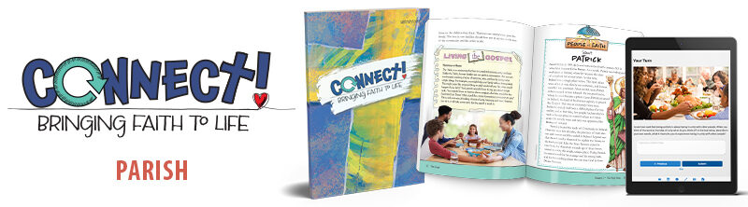

- The First Eucharist program comes from Dynamic Catholic . 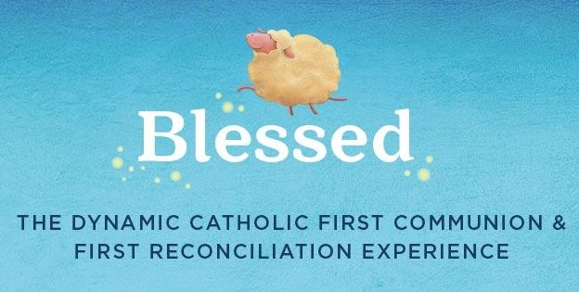

- Our ongoing Fundraising Campaign continues to collect refundable bottles and cans. This has allowed us to have a “No Cost” Faith Formation program since 2020. If you would like to contribute to this fundraising campaign please donate your bottles and cans. They can be bagged and left in the entranceway of the old rectory in Catskill, 66 William St.

If you would like more information about our program please email Michaela Anderson at: stpatrickff@aol.com or
Call 518-943-3150

To register for our program please follow the link below.

Faith Formation 2022-2023 Registration form

https://forms.gle/vEgw17yNz392xWMm6

